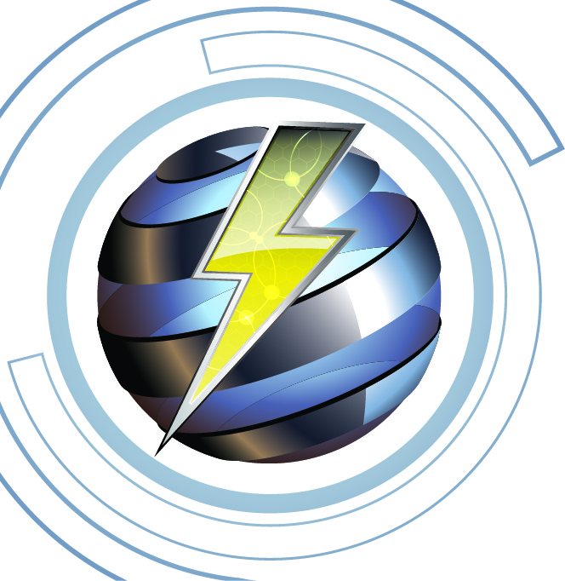

**Imlah Electrical Consulting 2-16-2022**

**Electrical Continuing Education, Grounding and Bonding Part 3**

**PowerPoint Slide Presentation, 4-Hr.**

**Course Outline, Instructor James Imlah _______________________________________________________**

**Course Description:**

4-hour presentation of the minimum installation requirements from the “14th Edition, *Soares Electrical Grounding and Bonding*” using the IAEI (International Association of Electrical Inspectors) presentation. This course will provide a Power Point presentation to meet the 4-hour requirements for individuals who hold a State of Utah Electrical License needing CC (Code Change) CEU credit.

**Course Objectives:**

The presentation will provide clarification and understanding of the minimum requirements for Grounding and Bonding of the “*National Electrical Code*” (NEC).

Presentation and discussion of the requirements for separately derived system, separate structures grounding and bonding, low voltage grounding and bonding

NEC articles will cover definitions, Article 250, and other NEC articles with grounding and bonding references back to NEC Article 250.

Training will allow attendees to ask questions and have open discussion for what effects grounding and bonding of electrical system requirements for low impedance paths for electrical installations.

**Class Content:**

Presentation will cover significant changes in the following Articles and Chapters:

Chapter 11 Grounding Separately Derived Systems 1-hour

Chapter 12 Grounding and Bonding at Buildings or Structures Supplied by Feeders or Branch circuits .75-hour

Coffee break .25-hour

Chapter 13 Bonding Enclosures and Equipment, 1-hour

Chapter 14 Equipment Grounding conductors 1-hour

**Materials Required:**

Current published NEC (NFPA-70) model code.

**Presentation Materials:**

Program presentation using “*Soares Grounding and Bonding*, IAEI Power Point Slides

**Course Attendees**

This course is designed for all Washington licensed electricians. Additionally, the training is open to others such as engineers, apprentices, trainees or other interested parties.

**Course Documentation**

Upon competition of the training, 4-hours of CC (Code Change) CEU's will be submitted to State of Utah within 10 working days.

A sign-in roster will be maintained for 5-years and made available upon request

Course survey forms will be given to on-site attendees and will be maintained for 5-years and made available upon request.

Attendees will receive by e-mail or onsite “Certificate of Completion” for the provided educational training