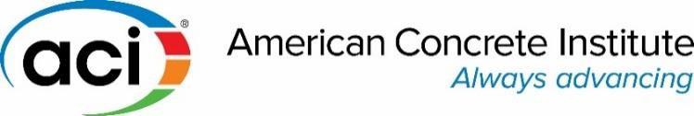

Chapter Technical Talks

Low Compressive Strength Test Results? What They Mean and Next Steps…

Compressive strength tests are used for concrete acceptance based on criteria defined in ACI 318 and ACI
301. Tests results not meeting these criteria are referred to as low strengths. This presentation covers the “low strengths” topic in detail and provides answers to questions such as: what is considered a strength test and what is not, what the minimum frequency of testing is, what the acceptance criteria for strength tests are, and how to investigate strength tests not meeting the acceptance requirements. In addition, steps needed by a concrete supplier, in case acceptance criteria are not met, will also be discussed. To better understand discussed concepts, the presentation will use statistical concepts and numerical examples. A list of reading resources will be provided for those interested to study it in more detail. Topics covered in this presentation include:
- Definitions related to strength testing
- Methods of sampling, fabrication, handling, and curing strength test specimens
- Acceptance criteria for strength tests
- Interpretation of strength test results not meeting acceptance requirements
- Investigation of non-compliant concrete
- Addressing low strength concrete issues in production

Date: March 14, 2023
Time: 12:00PM MST
Location: SCHEELS
11282 S State St. Sandy, UT 84070
Robert Howell joined ACI as Professional Development Program Engineer in 2014. Previously, he was a Lead Structural Engineer at IBI Group, formerly Giffels Associates, Inc. Robert has 26 years of structural design experience in health care, industrial, research, power plant, educational, and commercial facilities. He also has 7 years of experience as an Owner’s Representative Project Structural Engineer with GM Worldwide Facilities Group. He received his BS in Civil Engineering from Wayne State University and his MBA in Supply Chain Management from Michigan State University; he is a licensed Professional Engineer in Michigan.

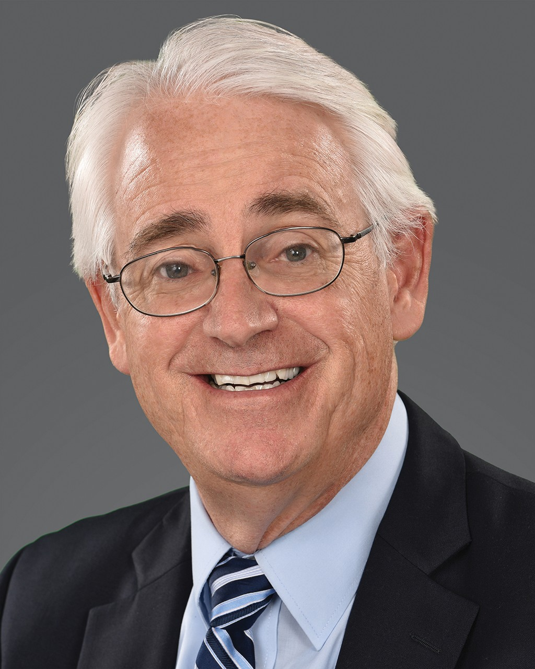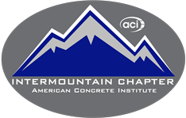

Questions: Denesha Price, Chapter Activities Coordinator
Denesha.Price@Concrete.org or 248.848.3830

