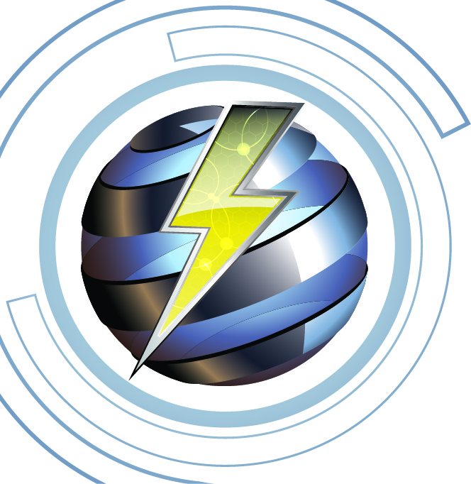

**Imlah** ***Electrical Consulting*** 12-15-2023

**Electrical Continuing Education, 4-Hr. Code Related**

**“Fundamentals of the NEC”**

**Instructor James Imlah**

**Course Syllabus:**

This 4-hour electrical training course with discussion about how the electrical code is laid out and general electrical installation requirements with the 2023 NEC requirements for a code compliant installation using listed products. The Code Related technical training module will include code questions to help attendees understand and ask questions for the general requirements of specific to electrical installations. Topics being presented are the following:

Article 90, Introduction to the National Electrical Code

Article 110, General Requirements for Electrical Installations

Article 300, General Requirements for Wiring Methods and Materials

**Course content and time spent:**

* Introduction to the Code, .75-hour
* Basic general requirements for a code compliant electrical installation, 1 1/2-hour
* Coffee Break .25-hour
* Basic general requirements for electrical wiring and acceptable materials,1 1/2-hour

**Course Objectives:**

* Article 90 will provide information for what type of installations are covered, code book arrangement, and rules.
* General discussion of the layout of the electrical code and able to understand mandatory and optional to meet the minimum rules
* Present why it is necessary that products are installed with the identified and listed products as per manufacturer’s installation requirements
* Discussion for electrical working clearances in and around equipment for under 600-volt installations
* Provide information how raceways and cables shall be installed in buildings and structures for physical protection
* Installation of conductors based on environmental and temperature considerations to associated with electrical terminations and equipment

**Resources Provided:**

PowerPoint Slide Presentation code

**This course will cover pats of the following NEC Articles:**

* Article 90
* Article 110
* Article 300

**Course outcomes:**

The purpose of the presentation is a training refresher for the minimum code compliance requirements. This will give the attendee an understanding what the effects to meet listing and labeling of electrical devices, environmental temperature considerations, and labeling and identification of equipment. There will be discussion on using identified termination devices and meeting the design torquing requirements.

**Course Attendees**

Course is intended if for all Utah licensed electricians, engineers, apprentices or trainees.

**Course Documentation**

* Upon competition of the training, 4 hours of CR (Code Related) CEU's will be submitted to the within 7 working days.
* A sign-in roster will be maintained for 5-years and made available upon request
* Course survey forms will be given to attendees and will be maintained for 5-years and made available upon request.
* Attendees will be provided by e-mail “Certificate of Completion” for the training presented