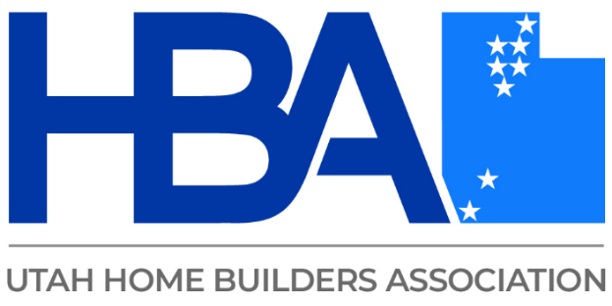

Top Performing Teams

This course covers construction business practices to create top performing teams resulting in supreme project management.

* The proper framework a contractor needs to hire and train a team in safety & proficiency that work together as a successful team.
* How to implement clear procedures and systems that contractors can implement in the construction business process to help improve their hiring and training development.
* Uncover the basic building blocks of communication and how to leverage it to drive growth.
* The best strategies for communicating with employees and clients for smoother project management.
* We will also teach the different methods available for improving communication effectiveness to ensure information is relayed in a reliable fashion to meet the codes & laws required in the building process.