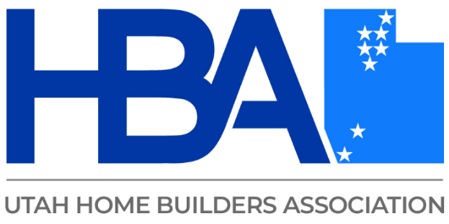
Cutting Edge Contracts
We’ll explore the legal principles and language that safeguard you, your business, and your peace of mind while ensuring you get paid for your work. Expect to leave with a clear understanding of the contract you need. Learn how to align your construction practices with your contract to protect your relationships, optimize your time, and maximize your profits.

