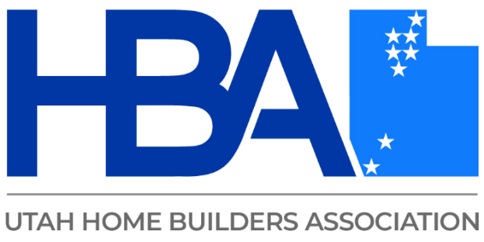



Managing Hazardous Materials

Topics to be covered:

Asbestos in Construction
- Asbestos Background
- Asbestos History
- Asbestos Uses
- Asbestos Health Effects
- OSHA Regulations
- EPA Regulations
- Utah DAQ Regulations
- Identifying Potential Asbestos
- Asbestos Inspections
- Removal of Asbestos Containing Material
- Asbestos in Demolitions and Renovations
- Reporting Requirements
Lead Based Paint (LBP)
- LBP History
- LBP Health Effects
- OSHA Regulations
- EPA Regulations
- HUD Regulations
- Utah DAQ Regulations
- Identifying LBP
- Safe Handling of LBP
- LBP in Construction
Other Potential Topics
- Mold
- Radon
- Air Quality

