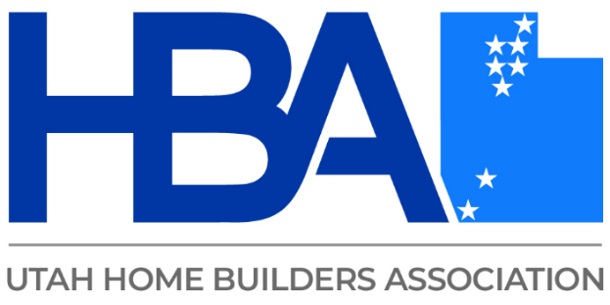

**Blueprint for Communication**

Altering directions to decrease misunderstandings

Type of conversations and how to approach them

Communicating code to clients

Advocating for you as a builder by utilizing the code

Communicating code to employees and decrease OSHA violations

Redirecting, approaching, and managing conflict with your team and when talking with clients.