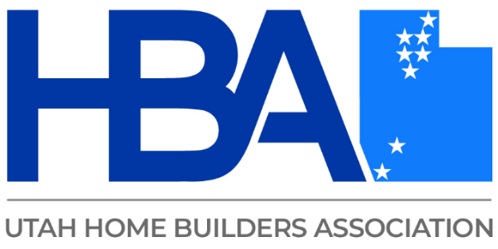

**Clear Talk Saves Costs**

Tired of repeating yourself or running into blank stares? This class helps you master tricky conversations by understanding different communication styles and learning how to adjust your approach.

You'll explore how to redirect confusion, reduce conflict, and connect more clearly in a variety of scenarios

* Relaying code requirements & instructions to employees & other contractors.
* Ensuring safety standards are understood
* Managing conflict with business associates-such as regulators, clients, & colleagues.

Build confidence in adapting your approach.