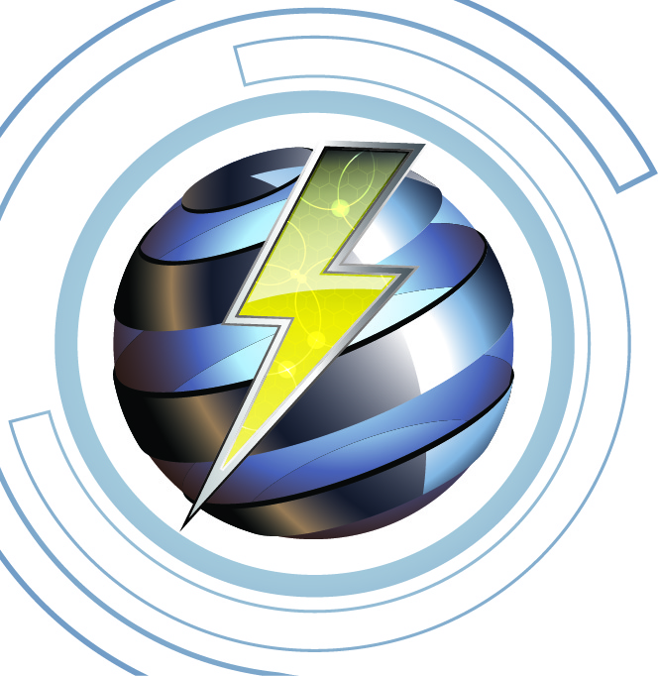
Imlah Electrical Consulting 5-6-26

Electrical Continuing Education, 4-Hr. Code Related
“2024 NFPA-70E, Safety in the Workplace Course Outline”
Instructor James Imlah

Course Description: 4-hour overview of the 2024 Edition of NFPA-70E for Electrical Safety in the Workplace. The presentation will include worker safety-related work practices, understanding OSHA Code of Federal Regulations, and safety related maintenance guidelines. This course will provide a Power Point presentation for all electricians for safety awareness and being vigilant of safety hazards when performing work on or near electrical equipment. This training will reference 2023 NFPA-70 & 2024 NFPA-70E code sections.

Course Objectives:
- Explain some of definitions as provided in NFPA-70E
- Understand potential hazards in the work place when performing work on possibly energized electrical equipment.
- Understand the rules of what is a “qualified persons” performing electrical tasks
- Provide assistance to understand and recognize safety hazards on the job.
- Provide clarification for lock-out/tagout process and procedures

Training Content:
- Definitions as related to Safety in the workplace .5 hour
- Application of OSHA & NFPA 70E Safety Related work practices and hazards 1.25 hour
- Coffee Break, .25 hour
- Implementing 70E Electrical Safety program, safety awareness, proper PPE 1.5 hour
- Provide training and clarification for lock-out/tagout procedures, .5 hour
- Discussion of related electrical incidents with hazards and injuries .5 hours
Reference Materials:
- 2023 National Electrical Code (NFPA-70
- 2024 Safety in the Workplace (NFPA-70E)

NFPA 70E Code References
- Chapter 105 Safety-related work processes
- Chapter 110 Requirements for electrical safety
- 110.16 ARC Flash Warning
- 110.21 Equipment Markings
- Chapter 120 Electrically safe working conditions
- Chapter 130 Work involving energized equipment
Course Attendees
This course would be primarily for journeyman electricians, general and plant supervisors, plant journeyman, and limited maintenance electricians. Other individuals such as engineers or apprentice electricians. Any licensed electrician in the State of Utah can receive up to 4-hours of CR (Code Related) CEU’s for attendance.
Course Documentation
Upon competition of the training, 4 hours of CR (Code Related) CEU's will be posted to the State of Utah within 7 working days.

A sign-in roster will be maintained for 5-years and made available upon request

Course survey forms will be given to attendees and will be maintained for 5-years and made available upon request.

All attendees will receive a certification of competition for the training being provided.

