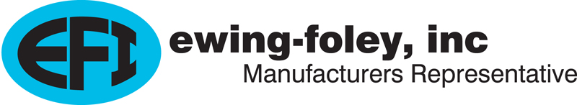
Ewing-Foley, Inc. Continuing Education Training
12/12/2025
Electrical Continuing Education
4-Hour Power point slide presentation: NEC ARTICLES 240 & 242
Instructor Ralph Bliquez
APPLICATION FOR A 4-HOUR CODE CHANGE CLASS ON OVERCURRENT/OVERVOLTAGE PROTECTION
2023 NEC, ARTICLES 240 & 242

The scope of Article 240 provides the general requirements for overcurrent protection and overcurrent protective devices to provide protection for conductors and equipment if the current reaches a value that will cause an excessive or dangerous temperature that will damage the conductors, conductor insulation or equipment.
The following code articles that include changes and revisions in the 2023 NEC will be in the Power Point presentation:
240.2 Definitions: Changes in how definitions are sited in Chapter One
240.4(G) Revisions
240.6(C) Access to Adjustable Trip Breakers
240.21(B) Feeder Taps
240.33 Vertical Position
240.62 Reconditioned Equipment
240.67(A-C) Arc Energy Reduction (Fuses)
240.87 (A-C) Arc Energy Reduction (Breakers)
240.90 (B) Devices Rated over 800 Amps
These changes will be addressed as the class goes through the entire Article and should take substantial time. My “dry” run-through took one hour for the changes. The rest of Article 240 was two hours for a total of three hours.
Information on other articles in 240 can be found in the Power Point attached.

The scope of Article 242 is to provide the general requirements, installation requirements and connection requirements for overvoltage protection and overvoltage protective devices. Permanently installed Surge Protective Devices (<1000 volts nominal) and Surge Arresters (>1000 volts nominal) are treated separately
Note: Every entry in Article 242 is “New” because the chapter is a combination of the previous Articles 280 and 285.
Specific attention will be given to the following two articles:
242.3 Specific Equipment Protection
242.6 Uses not Permitted
Article 242 is short and, with the changes, took one hour as I went through the entire article.
Information on other articles in 242 can be found in the Power Point attached.

COURSE OBJECTIVES
The objectives of the class on Articles 240 and 242 are to cover the general requirements for protection of conductors and equipment from hazardous overcurrent and overvoltage forces.
LEARNING OUTCOME
Electricians will understand the importance of the proper sizing and installation of overcurrent and overvoltage devices for the protection of conductors and equipment.
INSTRUCTOR
The instructor is Ralph Bliquez who is currently approved in Oregon, Washington, Idaho, California, Utah, Montana, and North Dakota

