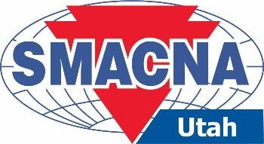
Project Rescue

When: October 15, 2026
Where: Sheet Metal Education and Training Center
Location: 2480 South 3400 West – Salt Lake City, UT 84119
Time: 7:30 a.m. – 8:00 a.m. Breakfast
8:00 a.m. Program Start
12:00 p.m. Program Concludes
Target Audience: Journeymen, Owners, Foremen, General Foremen, and Project Managers.

This Course Provides 4-hour Professional CEU

Program Description: Not all projects go as planned. Identifying when a project may need rescue and implementing preventive measures can be key to a successful outcome.
Key Program Objectives:
  - How to identify a project heading south
  - How to investigate the why
  - How to course-correct for a profitable outcome
  - How to take legal action

About the Speaker: Walead Atiyeh is an Associate Director at Maxim Consulting Group, working with construction-related firms of all sizes to evaluate business practices and assist with management challenges. His areas of expertise include strategic management, planning, estimating, sourcing, and project management.

There will be no charge to attend this course. RSVP by Thursday, October 8, 2026.

Name:
Name:
Name:
Company:

Register online at www.smacnautah.org or return this form via e-mail to Shelley Lester at shelleylester@sisna.com.

