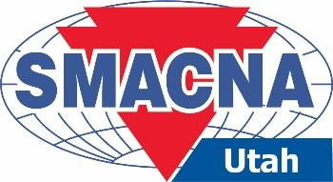
PROJECT PLANNING FROM PRECONSTRUCTION TO CLOSEOUT AND DIRIVING PROJECT SUCCESS

When: November 12, 2026
Where: Sheet Metal Education and Training Center
Location: 2480 South 3400 West – Salt Lake City, UT 84119
Time: 7:30 a.m. – 8:00 a.m. Breakfast
8:00 a.m. Program Start
12:00 p.m. Program Concludes
Target Audience: Journeymen, Owners, Foremen, General Foremen, and Project Managers.

This Course Provides 4-hour Professional CEU

Program Description: Successful projects are the result of effective planning, strong leadership, motivated teams, and disciplined execution throughout the project lifecycle.

This interactive session places participants in a real-world scenario where they must navigate the challenges of delivering a project without having all the information, resources, or tools they need demonstrating the importance pre-planning and collaboration.

About the Speaker: David Morton is a Director at Maxim Consulting with 30 years of experience in construction and manufacturing. His expertise includes C-level leadership, operations management, leadership development, contract negotiations, project execution, financial planning, and business development.

There will be no charge to attend this course. RSVP by Thursday, November 5, 2026.
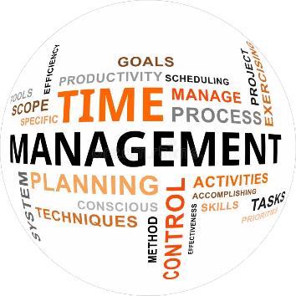
Name:
Name:
Name:
Company:

Register online at www.smacnautah.org or return this form via e-mail to Shelley Lester at shelleylester@sisna.com.

