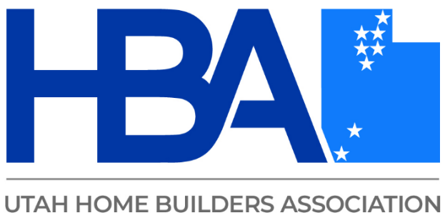
The Profit Leak
Finding (and Fixing) What's Silently Costing Utah Contractors
Where is your contracting business quietly losing profit?
This practical course helps contractors identify hidden profit leaks across six critical areas of the business: marketing, sales, pricing, team management, systems, and AI efficiencies. You’ll learn where money may be slipping through the cracks—and, more importantly, what you can do to fix it.
Attendees will:
- Calculate their target-profit numbers and understand what their business needs to earn.
- Score their business across all six profit-driving pillars to identify strengths, weaknesses, and opportunities.
- Discover practical ways to increase profitability without simply working more.
- Identify missed opportunities to use AI to improve efficiency and reduce wasted time.
- Learn CEPA-based exit-planning fundamentals to begin building a business that has value beyond the owner.
Walk away with a clearer picture of where your business stands, where profit is being lost, and the specific areas that can have the greatest impact on your bottom line.

