Title
The Back Saver System, a new, comprehensive approach shown to reduce the most expensive issue in the workplace; back pain.

Time/Format
4 hr course
Description
You can forget the fluff and abstractions. This course will give you real, hard-edged, immediately usable, value-packed, results-oriented information. This is the only course that includes an actual demonstration to attendees on how they themselves can put their own back, "back in", after they have "put their back out". Peter Guske PT tackles the first of the “Big 3”: The overwhelming share of all the expenses for an employer’s healthcare goes to no more than 3 conditions: 1) Spinal Pain (lower back pain), 2) Fatigue/Diabetes, and 3) Heart Disease/Hypertension/Hi-Cholesterol/Overweight. In this course he takes on “Number 1”: back injuries, the single most expensive issue in all of healthcare and the most common musculoskeletal job-related injury. Using the highly unique, lively and innovative demonstrations and animated manner that has been his trademark, Peter Guske PT utilizes brand new, pioneering research and his own highly-unique experiences as he parts company with the traditional approaches used by industry and many healthcare professionals to reduce the enormous costs for any employer directly associated with this issue. In the same way as he has objectively demonstrated for results-oriented companies all over the country, he challenges the long-held beliefs that aerobic exercise, stretch/flex, “feel good” exercises, core strengthening, or even teaching “correct lifting” have been effective, since none of these have demonstrated cost savings, or reductions in back injuries. He outlines a low-cost, highly-effective approach that can be utilized by anyone, at any age with no expensive equipment and in a tiny fraction of the time and space needed for the typical gym workout or wellness exercise routines. He also answers the ultimate question: “If this new approach works so well, why isn’t everyone doing it?”

Objectives:
- Understand the rationale for performing internal body leveraging and can perform new, unique self-mobilization.
- Explain exactly what is happening inside the spine and why traditional educational programs, aimed at reducing the incidence of back injuries on the job, have been largely ineffective.
- Utilize new demonstrated instruction techniques that allow you to approach back pain in a much more direct, accurate and time efficient manner in any work setting.

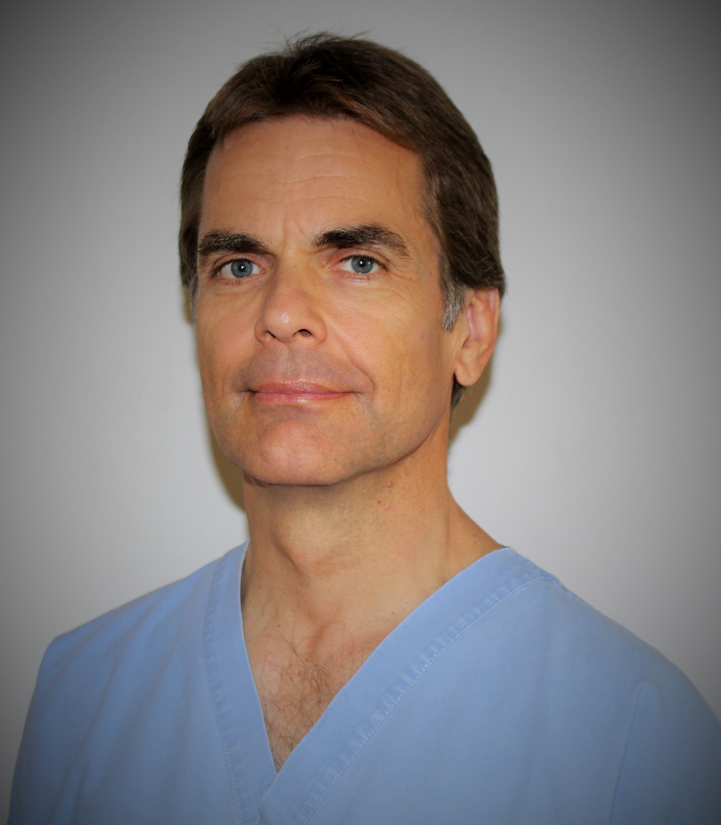
Biographical Information
Peter Guske PT is a licensed physical therapist with 24 years of clinical experience treating back pain and other injuries in the hospital, out-patient and home-care setting. He is a former competitive bodybuilder and he obtained his Bachelor of Science in Physical Therapy from Wayne State University, Detroit. He worked in Los Angeles developing the first rehabilitation protocols for ultramodern lower back testing equipment for Nautilus Sports Medical Industries/MedX, working directly with Arthur Jones, creator of the Nautilus empire. Mr Guske opened his own rehabilitation clinic in Florida and has gone on to build The Back Saver System, successfully integrating health with safety and the only comprehensive, low-cost, single-source, nationwide, employee wellness training program, provided on-site, which actually demonstrates how you can put your own back, “back in”. In what may be a record in the industry, in a 4-year period, Mr Guske has instructed over 14,000 individuals across the United States using this results-oriented, highly nontraditional system. Clients include Solvay Mining-Wyoming, Western Kentucky Energy, Florida Lake Co-Generation, Minnesota Power, Arizona Electric, Kinder Morgan, Cargill Feed, General Electric, Texas National Guard, Utah Kern River Gas Transmission, multiple Offshore Platforms and many others.

Speaking Experience:
Peter Guske’s presentation was again recently rated as, by far, the best presentation at the Annual HSE Conference of the International Associating of Drilling Contractors, Houston.
He has made over 450 paid instructional 4-8 hour training presentations to groups of 20 to 600 attendees.
In addition to presenting at numerous medical and rehabilitation conferences, he has made keynote or breakout presentations, over the last 15 years, at all the following state level annual safety conferences:
- Alabama Annual Safety Conference
- Arizona Annual Safety Conference
- Colorado Annual Safety Conference
- Iowa/Illinois Annual Safety Conference
- Kentucky Annual Safety Conference
- Maine/New Hampshire Annual Safety Conference
- Minnesota Annual Safety Conference
- Nebraska Annual Safety Conference
- New Jersey Annual Safety Conference
- North Carolina Annual Safety Conference
- North Dakota Annual Safety Conference
- Oklahoma Annual Safety Conference
- South Dakota Annual Safety Conference
- Tennessee/VPPA Annual Safety Conference
- Utah/Idaho Annual Safety Conference
- Wisconsin Annual Safety Conference
- Wyoming/Montana Annual Safety Conference

Partial List of References:
Anthony Carter CSP- Kinder Morgan Pipeline-Senior Safety Manager
Corky_Carter@kindermorgan.com
615-221-1514 office
615-714-1926 cell

Logan Stewart- Aleris Aluminum-Safety Superintendent
Logan.Stewart@aleris.com
270-295-5150 office
270-562-1704 cell

Jim Ed Burris- Western Kentucky Energy-Corp Safety Manager
James.Burris@bigrivers.com
270-844-6198

Heidi Franklin-Kinder Morgan-Safety Representative New York
Heidi_Franklin@kindermorgan.com
860-663-6031 office
713-204-7148 cell

Jim Garrison CSP-Muscatine Power and Water-manager Health and Safety
jgarrison@mpw.org
563-262-3560

