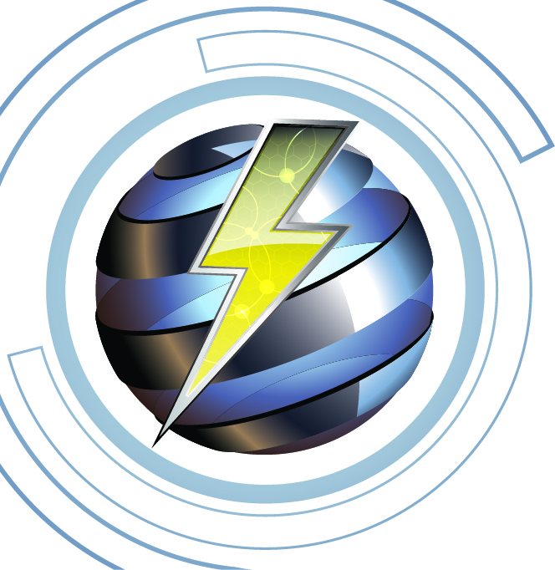

***Imlah******Electrical Consulting*** 1-20-20

**Electrical Continuing Education, 4-Hr 2020 National Electrical Code (Model) Code Changes**

**Power Point presentation, Chapters 5 & 6 to Article 682 of the NEC, Part 3**

**Course Outline, Instructor James Imlah _______________________________________________________**

**Course Description:** 4-hour overview of the significant changes for the 2020 National Electrical Code (NFPA-70), This course is a Power Point presentation of model code only to meet part of the minimum requirements for individuals who hold a State of Utah Electrical License.

**Course Objectives:**

* Understand the changed requirements added to the National Electrical (Model) Code
* Understand the electrical minimum requirements when the 2020 NEC is adopted and enforceable
* Individuals will be allowed time to ask questions and have open discussion for better understanding of the model electrical code changes for licensed installers
* The attendees will be permitted to ask questions to understand the effect of the 2020 NEC model code changes affecting electrical installations.

**Class Content:**

* Class to cover significant changes in the following Articles and Chapters:
* Chapter 5, Special occupancies *1.75* hour
* Coffee Break, 15 minutes
* Chapter 6 Special Equipment, 2.0 hour

**Materials Required:**

* Current published 2020 NEC, aka NFPA-70

**Materials Provided:**

* In-class presentation using the 2020 Analysis of Changes by IAEI Power Point Slides

**Course Attendees**

This course is designed for all licensed Electricians who only require model code change. Additionally, the training is open to others interested parties such as engineers or apprentices.

**Course Documentation**

* Upon competition of the training, 4 hours of Code Change (CC) (NEC Model Code) CEU's will be submitted to the State of Utah within 10 working days.
* A sign-in roster will be maintained for 5-years and made available upon request
* Course survey forms will be given to all attendees and will be maintained for 5-years and made available upon request.
* Attendees will be provided a “Certificate of Competition” for the Electrical Training