Blake Wentz, PhD, CPC, LEED ®AP
California State University, Chico
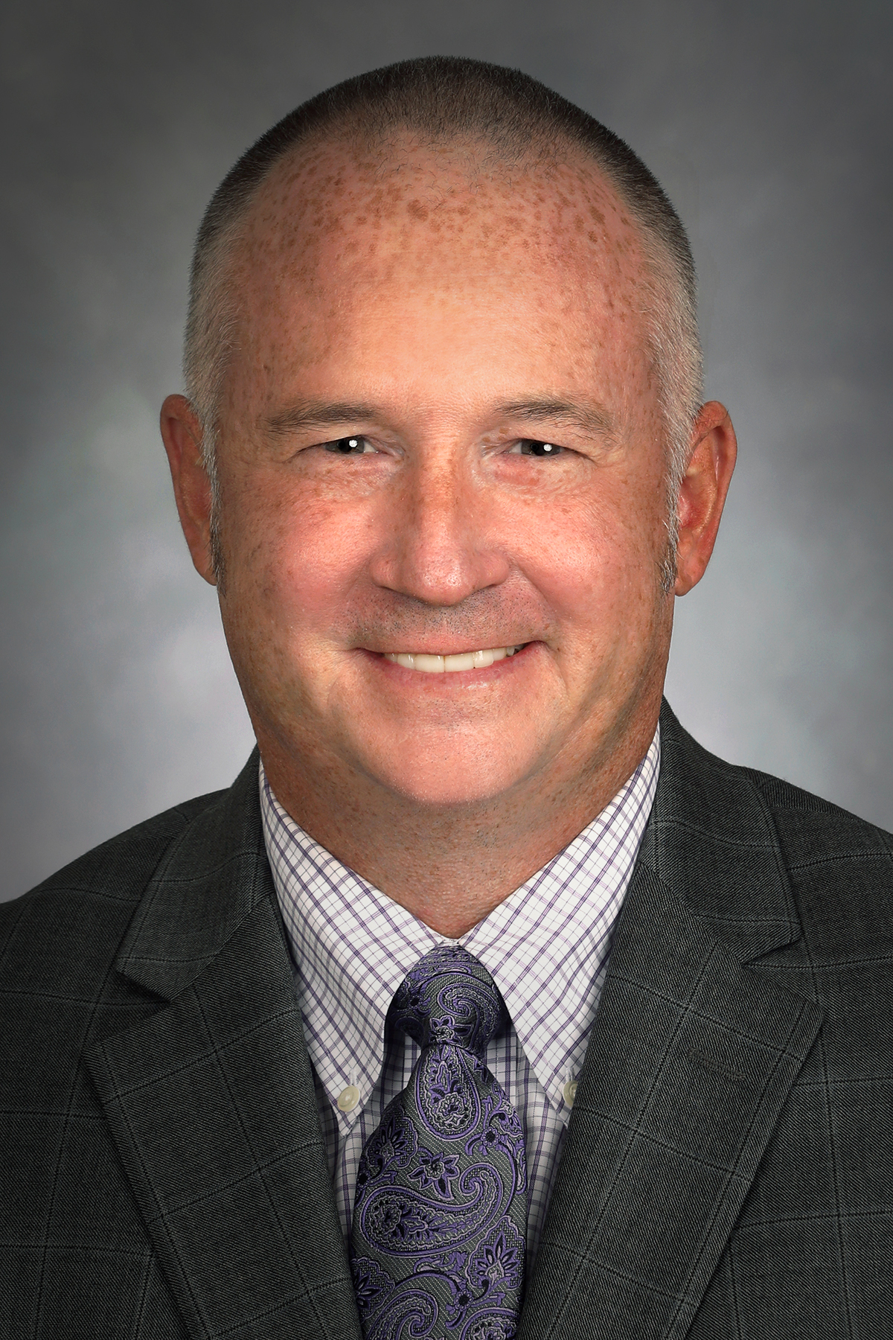
Dr. Wentz has a Bachelor’s degree in Finance and a Master’s degree in Engineering from the University of Nebraska, and a PhD from Indiana State University. He owned and operated his family’s mechanical contracting business, Wentz Plumbing and Heating, in Lincoln, NE for five years before becoming a college professor. He was a professor at the Milwaukee School of Engineering for 15 years, serving as Program Director of the Construction Management Program from 2008 to 2013, and then was promoted to Department Chair of the Civil, Architectural Engineering and Construction Management Department from 2013 to 2020. Dr. Wentz was named the Dean of the College of Engineering, Computer Science & Construction Management at California State University, Chico in July 2020 and is currently serving in that role. He was the faculty advisor for the Mechanical Contractors Association of America (MCAA) Student Chapter, whose competition teams have qualified for the National Finals nine times, winning the National Title in 2011, 2013 and 2019. Dr. Wentz was named National Educator of the Year for the MCAA in 2011, 2012, 2015 and 2018. Dr. Wentz was also the Owners Representative for MSOE and was in charge of the design and construction of the Dwight and Dian Diercks Computational Science Hall as well as the Grohmann Tower project. He is also involved in consulting activities and has been an expert witness for construction legal disputes and is a co-author of a textbook titled “Construction Law for Design Professionals, Construction Managers and Contractors.” Dr. Wentz is also currently the 1st Vice President of the Associated Schools of Construction (ASC), an organization of over 100 different universities across the world, and will take over as International President in 2022.

