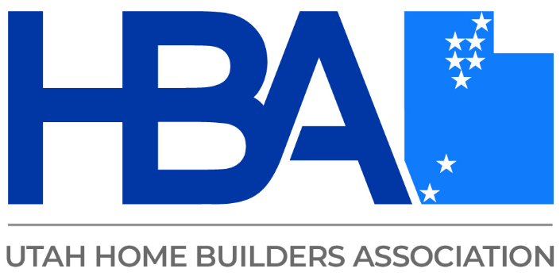

Steve Rogers & Nic Russell
Steve Rogers & Nic Russell have been advising and representing small businesses in Utah for over a decade. They have extensive experience in business formations and tax planning, drafting and negotiating contracts, insolvency issues, and litigation. Their number one goal as counselors is to make sure every client understands how the legal system can affect their lives for good or bad. Accurate information is key to making informed decisions, and Steve & Nic have counseled thousands of individuals and businesses to give them the information they need.

