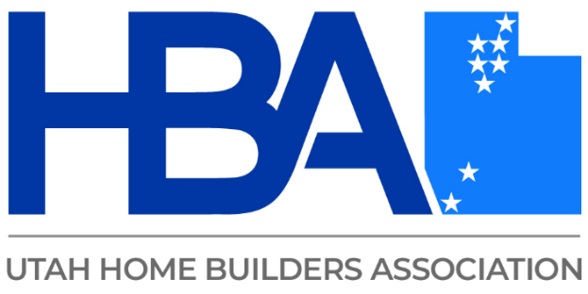

**Amber Mahrou**

* Vice President of Nevada and Utah regions, ARCXIS
* Proud graduate of Randolph-Macon Women’s College, double majoring in Political Science and Environmental Studies
* Master’s of Public Administration from University of Nevada, Las Vegas
* 15 years experience in energy efficiency and sustainability consulting, with experience in energy code design and implementation, HERS, Energy Star, DOE Zero Energy Ready Homes, EPA WaterSense, EPA Indoor AirPlus, LEED for Homes…