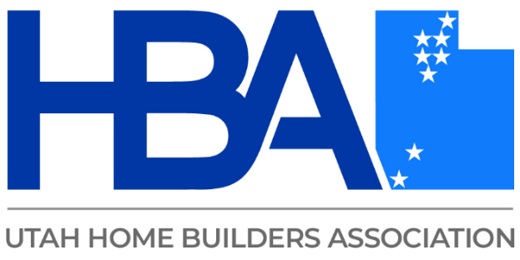

Troy Burton
Troy, the 17-year-old founder and owner of Rhino Foundation Repairs, has built a company specializing in concrete lifting and stabilizing sinking homes. Over time, the company has expanded its services to include waterproofing, deep soil injections, and commercial micropiles, among others. Rhino Foundation Repairs is rapidly becoming a leader in deep foundation systems, even pioneering its own pre-construction piling system. Passionate about the industry, the team enjoys educating others and assisting contractors in solving complex soil challenges.

