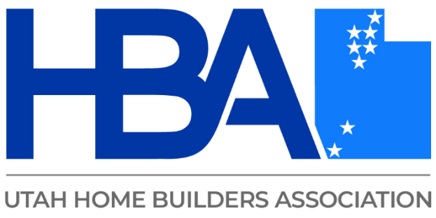

Scott Bainbridge

Scott Bainbridge is an environmental consultant and co-owner of Air Quality
Consulting, a Utah-based firm with over 50 years of combined experience specializing in air quality assessment and regulatory compliance.

With extensive experience in the field and a background as a General Contractor, Scott has provided expert analysis and solutions for major clients, including universities such as Brigham Young University and Utah State University, federal and state government agencies including the United States Army and Utah National Guard, and defense contractor Northrop Grumman.

In addition to his consulting work, Scott teaches state certification courses for the Rocky Mountain Center for Occupational and Environmental Health at University of Utah and Weber State University.

