Biography and Curriculum Vitae (Abbreviated)

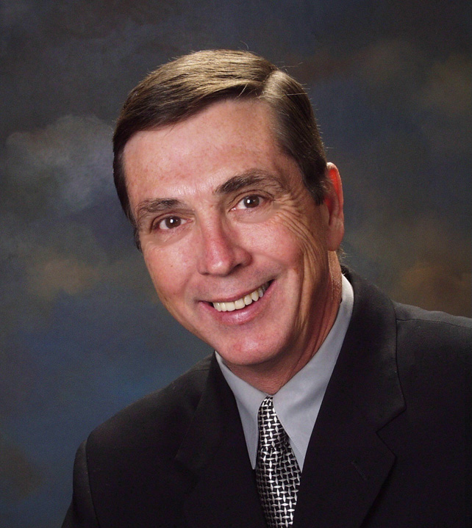
Larry Oxenham, Author, Senior Advisor
Larry Oxenham is one of America’s top asset protection experts, having helped thousands of professionals achieve financial peace of mind by teaching them how to properly structure their assets for lawsuit protection and tax reduction. He has authored and co-authored several articles and books on the subject including The Asset Protection Bible and How to Achieve Financial Peace of Mind through Asset Protection. His career has been credited with helping thousands of people save millions of dollars. Larry Oxenham is a nationally recognized speaker who has trained thousands of professionals at hundreds of conventions, conferences and seminars across the country.

Date of Birth: September 17, 1944

Place of Residence: Norman, OK

Memberships And Affiliation: Senior Advisor, American Society for Asset Protection
Aircraft Owners & Pilots Association

Education And Training: Mt. San Antonio College, Walnut, CA- Business Degree

Books & Articles:
Larry Oxenham, Protect Your Assets (Las Vegas, NV: American Society for Asset Protection, 2012)
Larry Oxenham and Cameron Taylor, How to Achieve Financial Peace of Mind through Asset Protection, (Phoenix,
AZ: Mount Lanai Publishing, 2008)
Contributing Author, Does Your Bag Have Holes?, (Phoenix, AZ: Mount Lanai Publishing, 2007)
Contributing Author, The Asset Protection Bible, (Salt Lake City, UT: Legal Protection Group, 2005)
Larry Oxenham, “A Proven Solution to Lawsuit Crisis,” 2003, NMFAP, Provo, UT
Larry Oxenham, “Medial Malpractice Crisis in America: Tort Reform Has Its Drawbacks,” Spring Hill
Review, April 2003, Brush Prairie, WA.

Past Speaking Engagements:
Over 20 years experience presenting educational seminars and workshops to hundreds of associations. Below are a few past speaking engagements. Date and location of these events are available upon request.

AAII Phoenix Chapter
American Galvanizers Association
American Institute of Inspectors
Apartment Owners Assn of Southern California
Associated Landscape Contractors of Colorado
Association of Progressive Rental Organization
California Self Storage Association
Caruba International
Discover U
Ecological Farming Association
Florida Building Materials Dealers Association
Golden State Coin Laundry Association
Greater Los Angeles Area PHCC
Kansas Contractors Association
Learning Exchange
Louisiana Pharmacists Association
Merchants Distributors Inc
National Assn of Insurance and Financial Advisors, AZ
National Assn of Waterproofing & Structural Repair Contractors
National Grocers Association
National Real Estate Investor's Conference
National Tile Contractors Association
Oregon State Association of Plumbing, Heating & Co
Quality Service Contractors
Washington Apartment Association
Wood Machinery Manufacturers of America
Academy of General Dentistry
Alabama Osteopathic Medical Association
Alaska Osteopathic Medical Association
Alpena General Hospital
American Academy of Environmental Medicine
American Assn. of Gynecologic Laparoscopists
American Association of Orthopaedic Medicine
American Assn. of Podiatric Physicians & Surgeons
American College of Surgeons, Florida Chapter
American College of Surgeons, Oregon Chapter
American Osteopathic College of Rheumatology
Arizona Podiatric Medical Association
Association of Black Cardiologists
Assn. of Military Osteopathic Physicians & Surgeon
California College of Osteopathic Family Physicians
California Orthopaedic Association
Charleston County Medical Society
Cleveland Academy of Osteopathic Medicine
Contra Costa Dental Society
FL Soc. of Otolaryngology-Head & Neck Surgery
Flying Physicians Association
Golden State Coin Laundry Association
Greater St. Louis Dental Society
Humboldt-Del Norte Dental Society
Iowa Podiatric Medical Society
Kingsbrook Jewish Medical Center
Mercy Medical Center - Des Moines
Michigan Optometric Association
Mid-America Orthopaedic Association
Minnesota Society of Anesthesiologists
Missouri Society of Anesthesiologists
Nebraska Academy of Family Physicians
New London County Medical Association
Northeast Louisiana Dental Association
Oklahoma Psychiatric Physicians Association
Oregon Podiatric Medical Association
Osteopathic Physicians and Surgeons of California
South Carolina Dental Association
SC Society of Plastic and Reconstructive Surgeons
Sunrise Hospital & Medical Center
Tennessee Podiatric Medical Association
Texas Urological Society
University Hospital of Brooklyn
Utah Academy of Family Physicians

