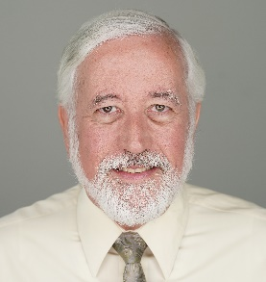
Brent Ursenbach- Bio
Ursenbach Code Consulting, LLC

Brent Ursenbach is an accomplished consultant specializing in building construction, mechanical, energy codes, and HVAC system design. With over 33 years in HVAC contracting and 13 years as a Salt Lake County Building Inspector, he has played a key role in advancing safety and efficiency standards. After retiring from Salt Lake County in 2018, Brent worked as a mechanical and energy code specialist for West Coast Code Consultants.
Brent has served on numerous ICC and ACCA committees, was Past President of RMGA, and chaired the Utah UBCC Mechanical Advisory Committee for eight years. He is an ICC Certified Building Official and a LEED BD+C Accredited Professional. He taught HVAC and code-related courses for five years as adjunct faculty at Salt Lake Community College. Brent regularly presents seminars on energy, mechanical, fuel gas and building codes, helping shape state code standards and educating professionals statewide. He received the 2019 Utah Chapter ICC Jess Miller Award and the 2024 Ed Evans Award. He holds a B.S. in Sustainability Studies from U-Mass Amherst UWW.

