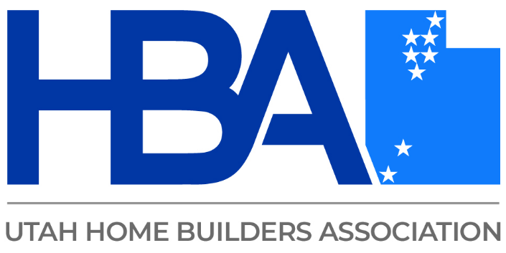

Alyssa Mitchell, MPA, CHES
Alyssa is a suicide prevention professional with the Utah Department of Health and Human Services, where she serves as the Suicide Prevention Program Manager. She leads statewide training and prevention initiatives, supports implementation of evidence-based strategies, and works closely with community and workplace partners to promote effective, responsible approaches to suicide prevention.

