Curriculum Vitae

William K. Shinn, P.E.

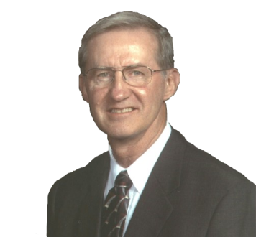
Education
May, 1970 -- BS Degree in Electrical Engineering, Power Option,
University of Missouri – Rolla.
June, 1996 -- MA Applied Behavioral Science-Managing & Consulting,
Bastyr University, Seattle, WA.

Licenses/Professional Societies
Registered Professional Engineer in Indiana
Senior Member of IEEE

Professional Experience
e-Hazard.com – Sr. Managing Partner 2004-Present
Offers training and arc hazard analysis to customers for electric arc under NFPA 70E, IEEE 1584 and OSHA 1910.269.

Feb 2002 to Present Safety Compliance Associates, Inc. & ArcWear.com
Electrical Safety consulting and training.

June 1970 to Feb 2002 ALCOA Aluminum, Inc., Newburgh, IN
1994 -Engineering and Maintenance Manager. Manage and lead 380
employees engaged in engineering and maintenance of a 60 million
pound per month aluminum smelting and rolling facility. Responsible
for a $36M capital budget, a $30M annual maintenance budget and all
safety for the division.

1989-2002 Chairman and member of Alcoa Electrical Safety
Committee.

1991 – Smelting and utilities Engineering and Maintenance
Superintendent. Responsible for all engineering and maintenance for
the Warrick primary metals division including the plant wide power
system.

1989 – Special assignment to corporate safety to survey all plants for
high voltage hazards and develop Alcoa Electrical Safety Standard
32.60.

1981 – Alcoa, Massena Operations, Chief Electrical Engineer for two
years then Maintenance Manager.

1970 – Various electrical engineering assignments including a new
HDC casting unit, two new kilns and five new substations ranging in
size from 2500 KVA to 100 MVA. Also was the plant power engineer.

E-Contact:
Bill.shinn@e-hazard.com

