Curriculum Vitae

Drake A. Drobnick, CSP, OHST
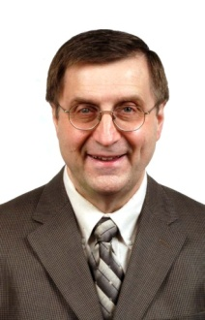

Professional Credentials:

CSP - Certified Safety Professional
OHST - Occupational Health & Safety Technologist
Licensed Journeyman Electrician: State of Michigan

Professional Affiliations:

Principal Member: National Fire Protection Association (NFPA)
Technical Committees: Electrical Equipment of Industrial Machinery (NFPA-79)
Electrical Safety for Employee Workplaces (NFPA-70E)
International Association of Electrical Inspectors (IAEI)
Governmental Affairs Chairman American Society of Safety Engineers (ASSE)
Certified ISO 14000 Internal Environmental Auditor
Member ANSI Machine Safety Standards Committee
Appointed Member: MIOSHA Construction Standards Committee

National Professional Safety Experience:

Consults and lectures nationally on the topic of electrical workplace safety

E-Contact:
drake@e-hazard.com

