@PolicyholderContactFullName@
@Policyholder@
@PolicyholderAddress@
@PolicyholderCityStZip@

@Today@

Dear @PolicyholderContactFirstName@,

We at WCF appreciate your business. As a valued owner, policyholder and business partner of WCF, your organization is eligible for our premium Safety and Health consultation services at no added charge.

I am excited to assist you and your organization with accident prevention and workers compensation cost control to contribute to your organization’s success. My qualifications include:
- Certified Safety Professional (CSP)
- Over 13 years of experience in occupational safety and health
- Provided Safety & Health Management Services to 4 different corporations
- Safety expertise in the manufacturing sector
- Provides specialized consultation in OSHA VPP (Voluntary Protection Program) and Ergonomics
- B.S. Degree in Safety Sciences from Indiana University of Pennsylvania
- Currently working towards MBA from the University of Utah

I will be contacting you to discuss the safety needs of your organization. In the interim, please feel free to contact me with your safety and health questions or concerns. I look forward to working with you.

Sincerely,

@Electronic Signature@
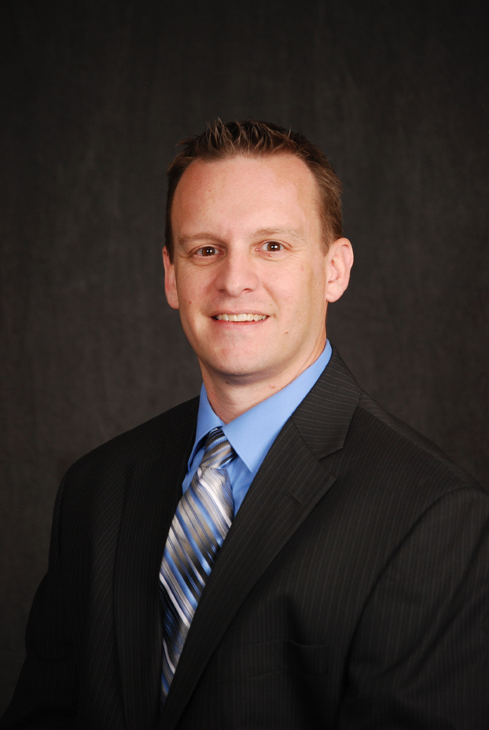
Brian Lichtenfels, CSP
WCF Safety & Health Services
Safety & Health Specialist
100 West Towne Ridge Parkway
Be Careful Out There!
Sandy, UT 84070
Office: 385.351.8303
Cell: 801.554.4759
blichten@wcfgroup.com

