@PolicyholderContactFullName@
@Policyholder@
@PolicyholderAddress@
@PolicyholderCityStZip@

@Today@

Dear @PolicyholderContactFirstName@,

We at WCF appreciate your business. As a valued owner, policyholder and business partner of WCF, your organization is eligible for our premium Safety and Health consultation services at no added charge.

I am excited to assist you and your organization with accident prevention and workers compensation cost control to contribute to your organization’s success. My qualifications include:
- Certified Safety Professional (CSP)
- M.S. Degree in Safety Management from Indiana University
- B.S. Degree in Health Science from Brigham Young University
- Over 10 years of experience in occupational safety and health
- Have worked as a Safety Professional in Manufacturing, Oil and Gas, and Mining industries

I will be contacting you to discuss the safety needs of your organization. In the interim, please feel free to contact me with your safety and health questions or concerns. I look forward to working with you.

Sincerely,

@Electronic Signature@
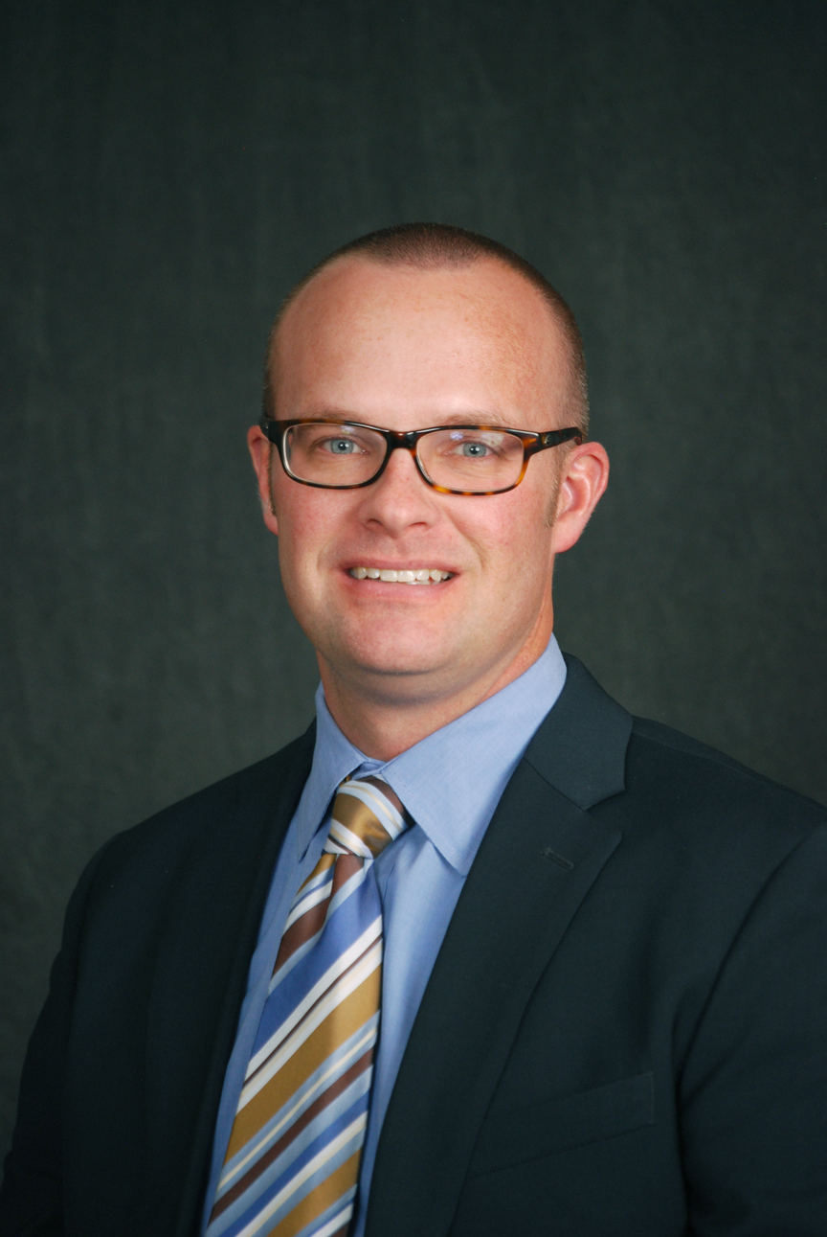
Matthew Thygerson, CSP, MS
WCF Safety & Health Services
Senior Safety & Health Consultant
100 West Towne Ridge Parkway
Be Careful Out There!
Sandy, UT 84070
Office: 385.351.8265
Cell: 801.550.4101
mthygers@wcfgroup.com

