Daniel Brian House
Instructor, Mike Holt Enterprises, Inc.
brian.house@mikeholt.com

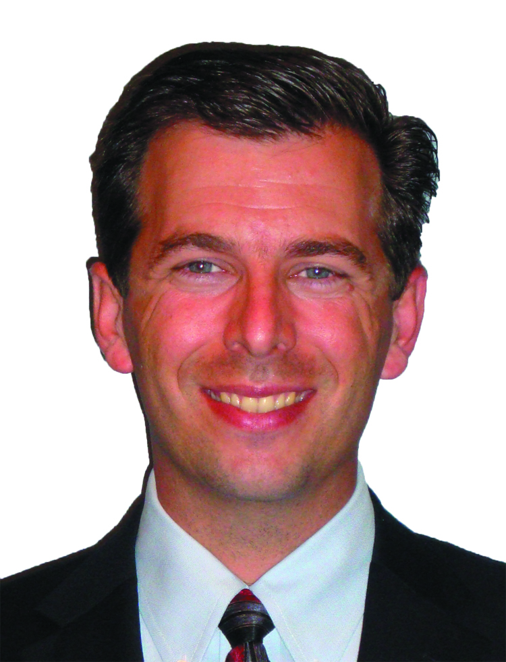
Brian House has extensive experience in the electrical field, from installation to management. He is currently the CEO of Dan House Electric, Inc., an unlimited electrical contracting company based in Florida and working throughout the southeast United States. Brian is developing training programs related to electrical code and safety for Mike Holt Enterprises, and travels the country presenting at seminars for Mike Holt.

Brian is a fifth generation Floridian, his father and grandfather being electrical contractors starting the family business in 1951. He worked in the electrical field since he was 8, starting out as shop help, and working his way up to Manager, and Owner today. At 13 he took an interest in computer programming, and started writing computer software in BASIC and PASCAL. Being very involved in the electrical field he turned his new found hobby toward the electrical field, writing a complete PLC based energy management software suite for a performance center prior to entering college.

Brian joined Mu Alpha Theta high school math club and competed in and won awards in several Florida science competitions by building a microprocessor controlled brushless DC motor. After graduating high school with a 4.7 GPA he received full academic scholarship offers from several private universities, and settled on Lee University where he received a full academic scholarship, and a scholarship position on the Cambridge University Semester program. While at Lee, he dual-majored in computer programming and Bible theology. He became a freelance sound engineer and ran sound nationwide for numerous labels. As a natural outworking of his activities in the Pro Audio world he moved into a part-time position working for Lee University in both performance centers, producing and managing various live events.

In 1999 Brian went to work for City Electric Supply in an outside sales position. Within a year he moved into management and obtained various manufacturer certifications for product sales and installation and an invaluable education on the workings of wholesale distribution. In 2000 he took a position as Field Supervisor for Top of the Line Industries, a company that was doing various residential commercial and industrial projects. Later that year, after taking the Mike Holt Enterprises State licensing class, he obtained his first state electrical contractor license.

In 2003, sensing an opportunity to move into the Limited Energy field, he opened First Class Systems of Florida doing IT and low voltage work. He immediately became a Certified Fire Alarm installer for several manufacturers and made that the focus of his business. Brian pursued training and was certified to the highest level for service and repair for residential and commercial standby generators. He worked side by side with Generac and presented small seminars teaching supply house employees how to sell generators to the electrical contractor.

Brian began doing electrical training in-house and attended the Mike Holt Enterprises “Train the Trainer” conference to enhance his presentation skills. Over the next few years he began finding opportunities to give electrical talks and teach electrical essentials to employees and local apprentices. He went on numerous mission trips to do electrical work in third world countries, projects ranging from small churches to orphanages, and schools.

