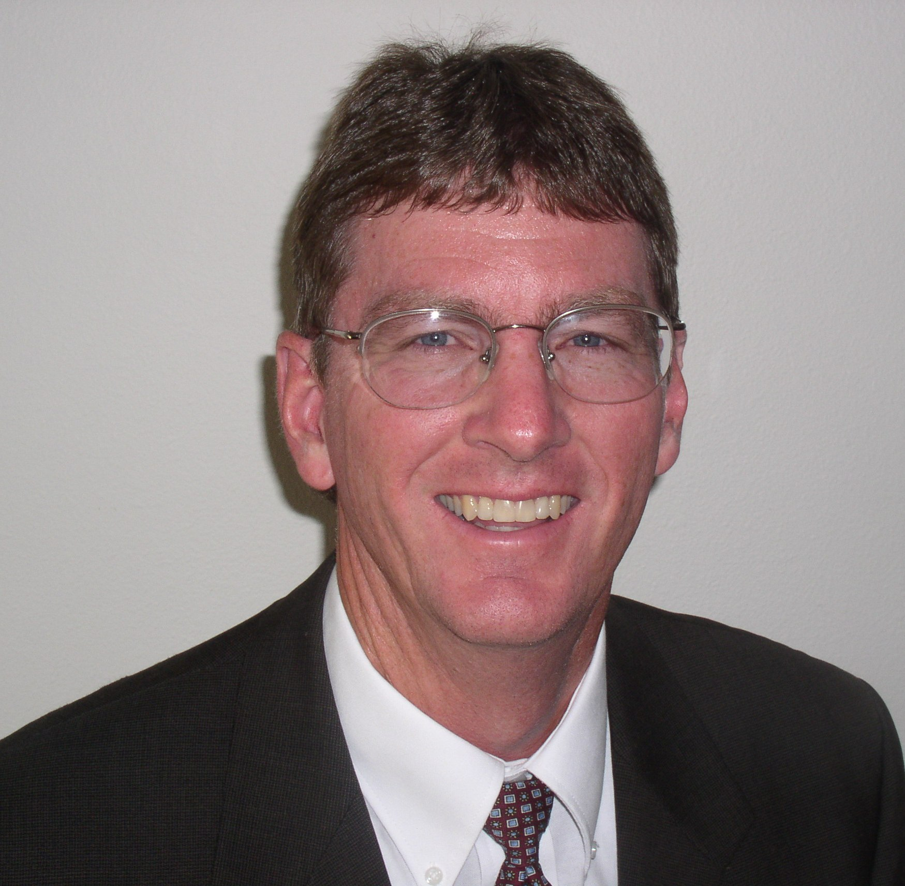
Lawrence E. Snow

Lawrence Snow, a 34-year veteran of the p-h-c industry, joined QSC on June 1, 2006 and serves as the Business Management Coach for a variety of services, such as comprehensive business analysis, strategic planning, competitive analysis, program/seminar development and more.

Snow began his career as an apprentice plumber and HVAC installer in 1975. He quickly moved up the ranks to become a service and repair plumber, trainer and solar expert with a Las Vegas contractor. In 1980 he was hired by another Las Vegas company and was soon the service manager with responsibilities for the entire company.

In 1982 he had the opportunity to purchase Anytime Plumbing, Inc. and also obtained his Master Plumbing license. He began transforming it into a leading company in his market. He continued to grow the company, achieving net profits well above industry averages. Anytime Plumbing grew from $25,000 to over $15 million by 1991 with 170 employees and had expanded from 3 to 50 service trucks. Snow had expanded the business to include underground utilities, commercial new construction and the largest grease trap and septic tank pumping operation in Las Vegas. He developed a grease and septic waste processing system allowing the company to “dewater” the waste and in turn sell the waste to landscape companies to use in their mulch.

After 17 years of being the business owner, Lawrence saw an opportunity to sell his company to a national consolidator of heating, air conditioning, and plumbing companies. He stayed on as location president and won awards for overall performance, loyalty and for double digit sales growth which also included double digit profitability reaching a high of 15.7%. During his time as location president, Lawrence was successful in purchasing other plumbing and HVACR businesses and merging the three companies together.

Snow went to work for a franchisor as Vice-President of Business Development for North America in 2002. During this time he was responsible for sales growth of the franchisees as well as technician/manager training and developing and presenting various training programs.

In 2004 he had the opportunity once again get involved in building a business from the ground up. He served as a consultant to his son on the purchase of a 12 year old company with one truck and yearly sales below $100,000. In the first year sales climbed to over $400,000 and profitability was in double digits. He sold the company in 2007.

In 2011 the business bug hit him again. He along with his son and nephew started Valley Plumbing and Drain Cleaning, another plumbing service and repair company in Northern Utah.

Throughout his business owner career, Lawrence has been dedicated to raising industry standards and educating business owners in the P-H-C industry. He is also a past member and trustee of QSC.

Lawrence resides in Lehi, Utah with his wife and children.

