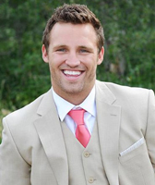

Chad recently began his career in the financial industry.  He is eager to continue building relationships with clients and helping them reach their financial goals. Prior to becoming a financial advisor Chad attended North Dakota State University where he received a B.A. in Public Relations and Advertising. In his time at NDSU he was a part of a National Championship football team and was also named an All-American.  Through these experiences he learned the importance of dedication and teamwork when looking to accomplish goals; he believes this will be an asset when working with clients.

Since graduating he has received Series 7 and 66 securities licenses.  Chad is determined to develop lasting relationships with clients while helping them prepare for a successful financial future.

In addition to his career, Chad is actively involved in his local church.  In his free time he enjoys being outdoors, playing sports, and spending time with his family.  Chad is married and has two sons.